**DAILY ONLINE ACTIVITIES SUMMARY**

|  |  |  |  |  |  |  |  |  |
| --- | --- | --- | --- | --- | --- | --- | --- | --- |
| **Date:** | **13-06-2020** | | | | | **Name:** | **Raksha S** | |
| **Sem & Sec** | **6th B** | | | | | **USN:** | **4AL17CS073** | |
| **Online Test Summary** | | | | | | | | |
| **Subject** | | **Python** | | | | | | |
| **Max. Marks** | | **30** | | **Score** | | | **28** | |
| **Certification Course Summary** | | | | | | | | |
| **Course** | **Introduction to Cloud** | | | | | | | |
| **Certificate Provider** | | | **Cognitive** | | **Duration** | | | **3 hrs** |
| **Coding Challenges** | | | | | | | | |
| **Problem Statement:**  1. Write a Python to implement Perfect Sum Problem.  2. Write a Java Program to remove all white spaces from a string without using replace. | | | | | | | | |
| **Status:** YES, Completed all Programs | | | | | | | | |
| **Uploaded the report in Github** | | | | | **YES** | | | |
| **If yes Repository name** | | | | | <https://github.com/raksha05/Daily-Status>/Raksha-4AL17CS073/Raksha | | | |
| **Uploaded the report in slack** | | | | | **YES** | | | |

Online Test Details:

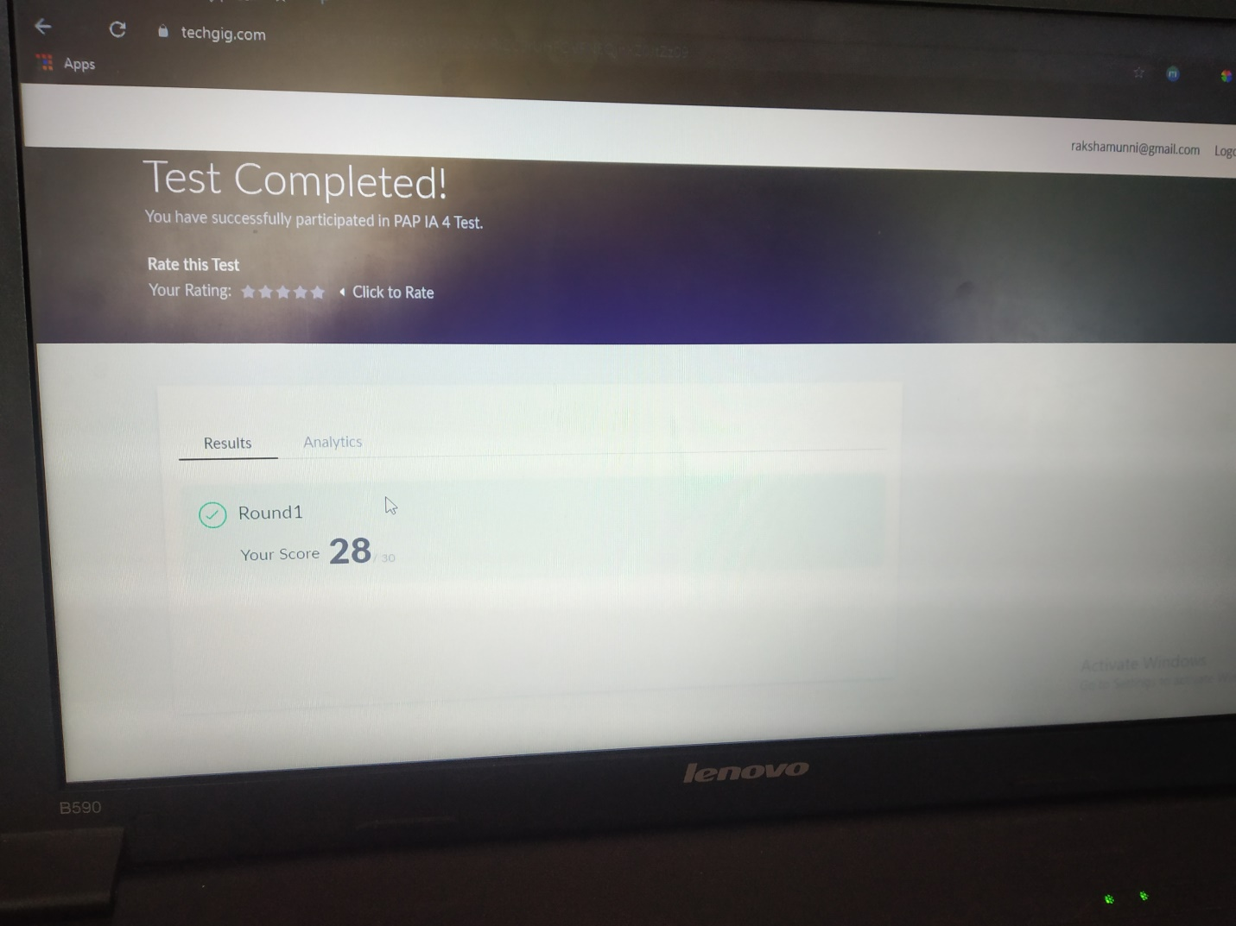

Scored 28 out of 30 in Python Test

Certification Course Details:

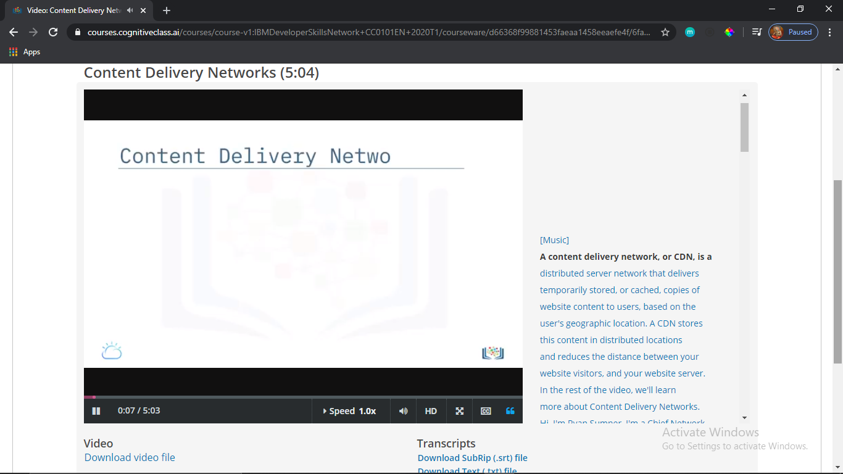

Today in certification based on Introduction to Cloud.Today I learnt about how storage in the cloud works,content delivery networks etc.,

Coding Challenges Details:

Program1:

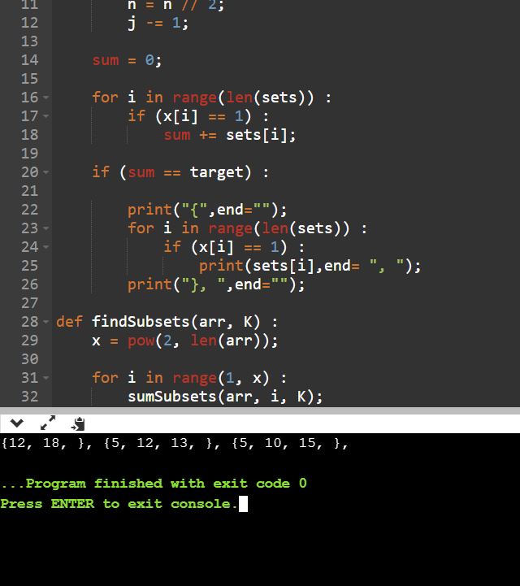

Program2:

